//A24586 Hyeonsu KIM

Assignment-7

//1

mongoimport customers-test-data.json -d company -c Customers –jsonArray

//2

db.Customers.dropIndex("LastNameCompoundIndex")

db.Customers.createIndex({"Name.First Name":1,"Name.Last Name":1},{name:"FirstNameCompoundIndex"})

//3

db.Customers.createIndex({"Name.Last Name":1,"Addresses.Full Address":1},{name:"NameAddressCompoundIndex"})

Before After

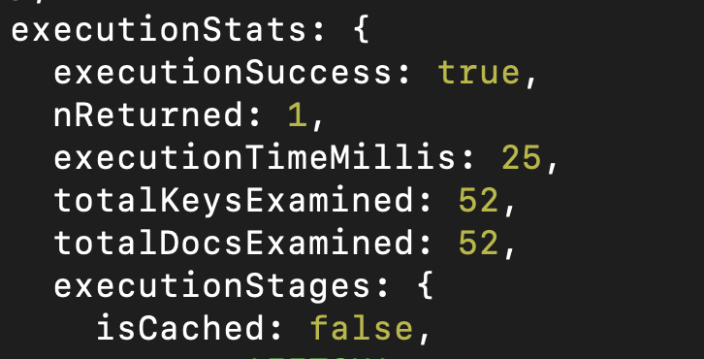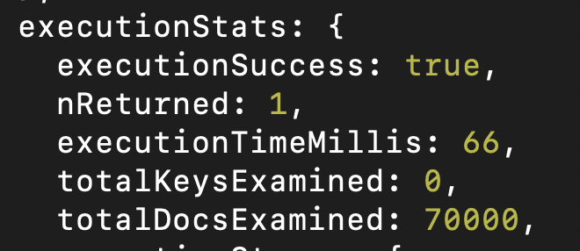

//4

use recipes

db.recipes.insertMany(

... [{"name": "Cafecito", "description": "A sweet and rich Cuban hot coffee made by topping an espresso shot with a thick sugar cream foam."},

... {"name": "New Orleans Coffee", "description": "Cafe Noir from New Orleans is a spiced, nutty coffee made with chicory."},

... {"name": "Affogato", "description": "An Italian sweet dessert coffee made with fresh-brewed espresso and vanilla ice cream."},

... {"name": "Maple Latte", "description": "A wintertime classic made with espresso and steamed milk and sweetened with some maple syrup."},

... {"name": "Pumpkin Spice Latte", "description": "It wouldn't be autumn without pumpkin spice lattes made with espresso, steamed milk, cinnamon spices, and pumpkin puree."} ]);

//5

db.recipes.find({$text: {$search :"spiced espresso"} });

//6

db.recipes.find({ $text: { $search: "espresso -\"ice cream\"" } });